Everyone moves at their own pace and range of movement. Remind them of breathing techniques and not to compromise form. Discipline is required to gain the full benefits. Designed for all levels

Anaerobic Exercises for Power- Timed
20 seconds for each exercise/ 10 second recovery
2x through for each set.

- Set #1: High Knees & Crunches (legs straight up/touch toes)

- Set #2: Burpee & Tricep Dips

- Set #3: Squat Jacks & Side Hip Raises

- Set #4: Alternating Lunges & Back Extensions

- Set #5: Squat Hold & Basic Pushup

Always provide modifications to accommodate each students level of difficulty!

Storyboard
- Set #1: High Knees & Crunches

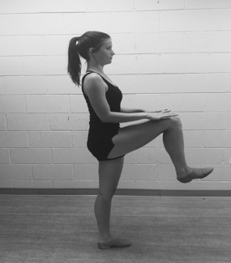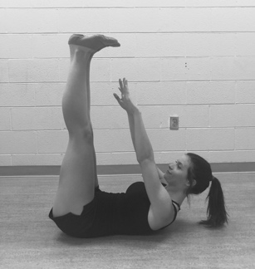

- Set #2: Burpee & Tricep Dips

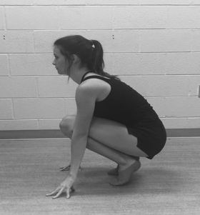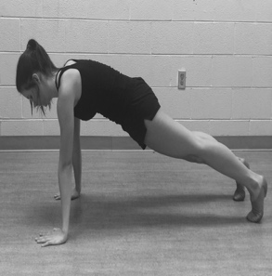

- Set #3: Squat Jacks & Side Hip Raises

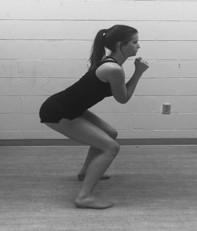
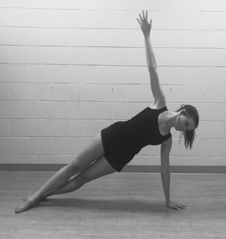

- Set #4: Alternating Lunges & Back Extensions

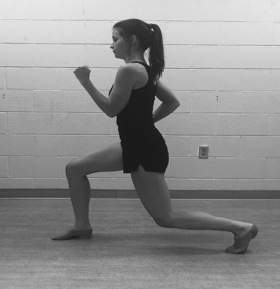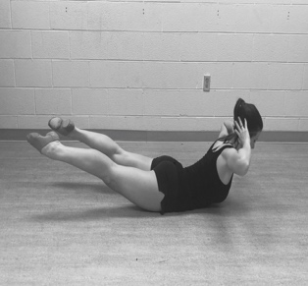

- Set #5: Squat Hold & Frog Jump

